Ideation Phase Empathize & Discover

Date | 28 September 2026
Team ID | SWTID-2026-2169
Project Name | Import Data Using Transform Map
Maximum Marks | 4 Marks

Empathy Map Canvas:

An empathy map is a simple, easy-to-digest visual that captures knowledge about the behaviors and attitudes of people who import data into Service Now, such as administrators, developers and HR or business users. It is a useful tool that helps the team better understand these users while they upload files, map fields and check the results of a Transform Map. Creating an effective solution requires understanding the true problem and the person who is experiencing it, for example the frustration of duplicate records or failed rows. The exercise of creating the map helps participants consider things from the user's perspective, along with their goals and challenges during the data import process.

Example:

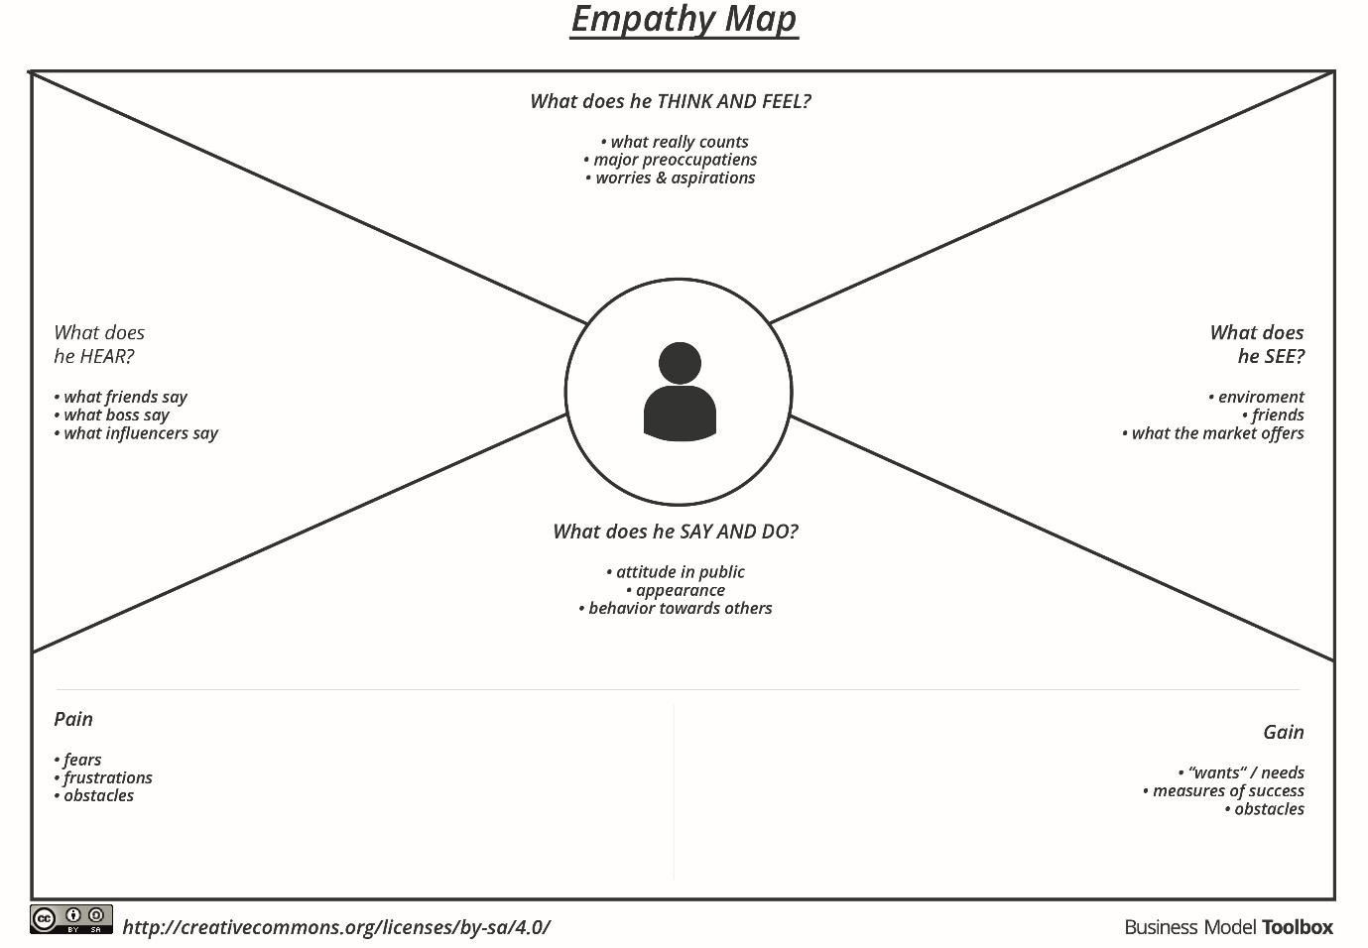

Example: Food Ordering & Delivery Application

What this
Annoying
dish look like?

Doesn't want frozen food

What should I eat today?
I'm hungry, but I don't have
time to go
downstairs

Why don't they provide
card payment

There are many food selections

Don't forget to prepare your cash

Think & Feel Menu without Only food photos cash payment
option
Hear a See

It looks like......

Say & Do
Driver Only
doesn't have cash payment
enough changes option

Godownstair I don't have
Spend 30 mins | Looking for | I couldn't
scrolling and | food that | find food
quit at the end | matches Interest | that I want

to pick up food and pay the driver In cash
enough cash with me right now

Pain
Hard to find them
food interests
Uncomfortable
paying cash
Looking for
food that matches interest
Gain
Comfortable
Accuracy

